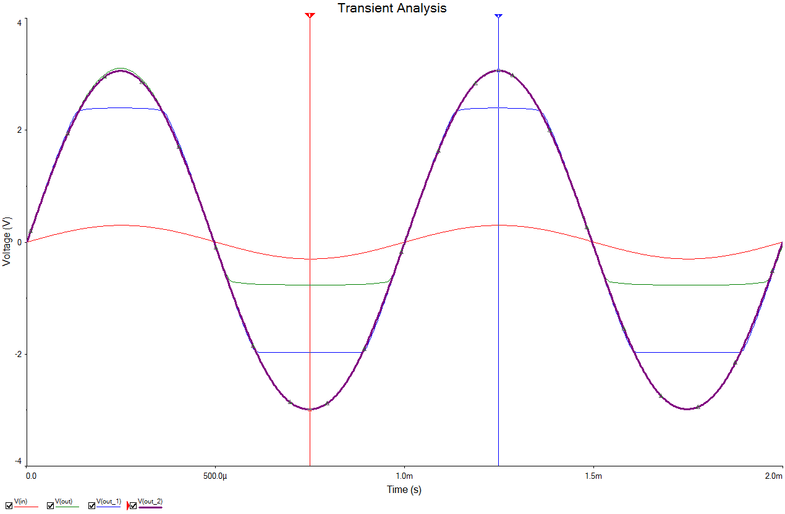

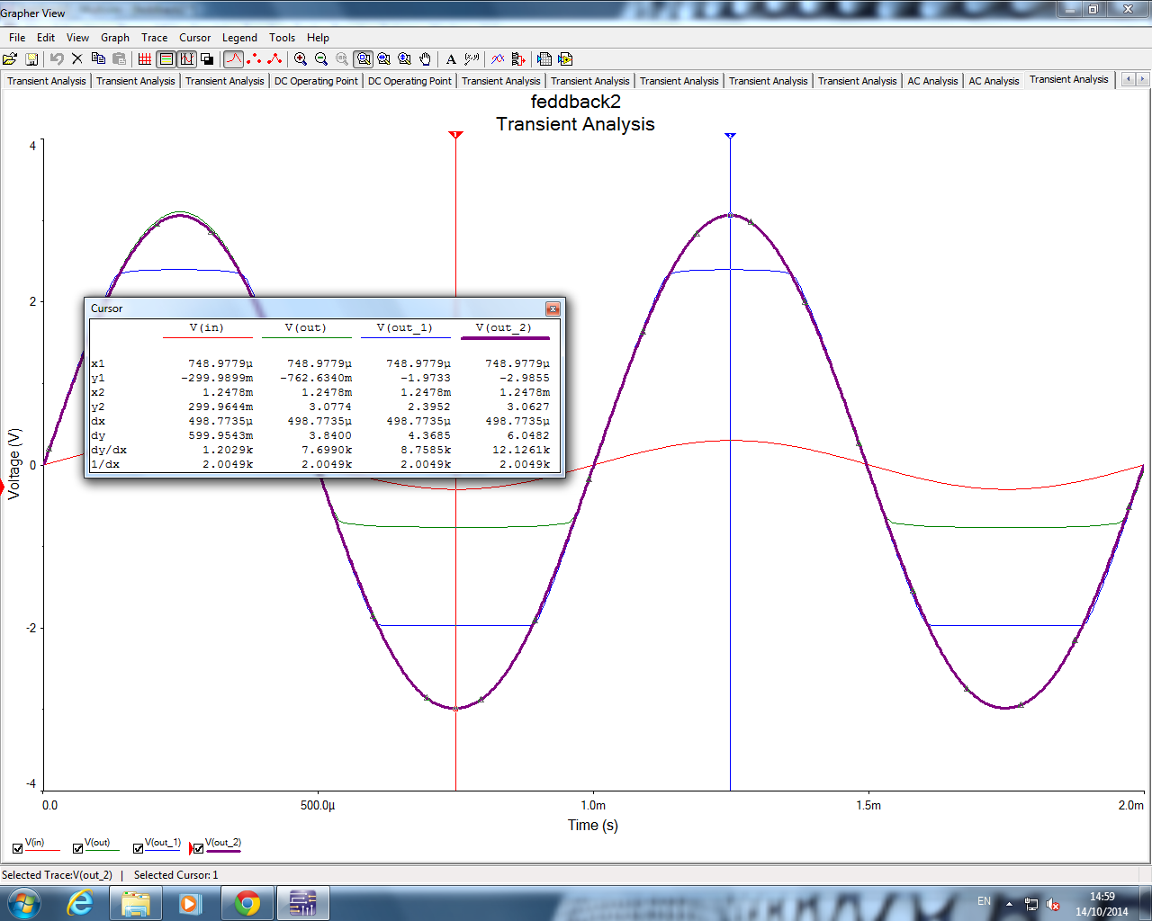

<http://hyperphysics.phy-astr.gsu.edu/hbase/electronic/feedn.html>